**Connect frontend with backend (ReactJS – NodeJs)**

Install **axios** to fetch data from backend

* **yarn add axios** or **npm install axios**
* import it in react file **– import axios from “axios”**
* use it as **axios.get(“data”)**

connection from react server to node server:

* react server – localhost:3000
* node server – localhost:5000

Two choices are here, either to use **cors** or **proxy** : -

1. cors

* install cors in backend (node.js) – **yarn add** **cors**
* import cors in index.js (node.js) – **var cors = require(“cors”)**
* use it as middleware – **app.use(cors())**
* now use axios to fetch data

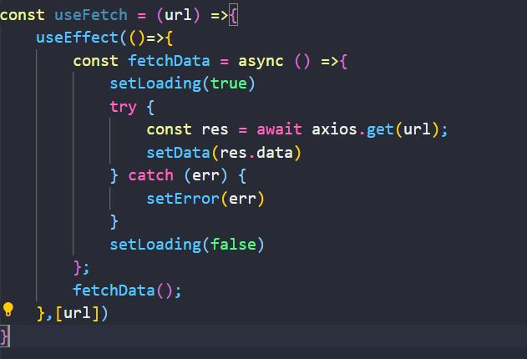



1. proxy

* give server endpoint in package.json of react file

as – “proxy”: ”http://localhost:5000...... ”

* now use axios with endpoints

in package.json -



in react file -

